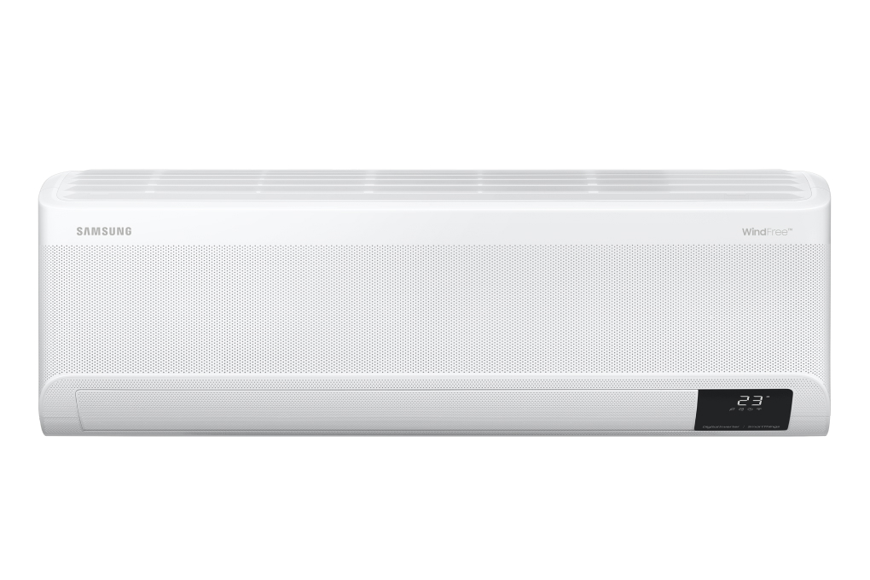

**20,990,000 VND** IN ADVANCE - Delivery from 7 - 15 days

**Promotion worth 1,300,000 VND**

Prices and promotions are expected to apply until 11:00 p.m. | December 31

first

Choose 1 of the promotions:

- No copper pipes and supplies will be given away.  
- Delivery only, no installation.

**Technical specifications of Samsung Inverter 2 HP AR18CYFAAWKNSV air conditioner**

* Machine Type:

1 way (cooling only) With Inverter

* Cooling capacity:

2 HP - 18,000 BTU

* Effective cooling range:

From 20 - 30m² (from 60 to 80m³)

* Dust filter, antibacterial, deodorant:

Copper Anti-bacteria Filter

* Power saving technology:

Digital Inverter BoostEco

* Rapid cooling:

Fast Cooling

* Utilities:

Good Sleep mode Wind-Free mode for comfortable cold air Dehumidifying function Freeze Wash deep cleaning function Auto Clean self-cleaning function On-off timer Smart refrigerator AI Auto Cooling Display screen temperature on the indoor unit Automatically restarts when power is restored Remote control via SmartThings application

* Power consumption:

1.77 kW/h 5 stars (Energy efficiency 5.2)

* Cooler:

Length 88.9 cm - Height 29.9 cm - Thickness 21.5 cm - Weight 10 kg

* Outdoor:

Length 72 cm - Height 54.8 cm - Thickness 26.5 cm - Weight 27.5 kg

Introducing the company 

- A brand from Korea, founded in 1938.  
- Samsung is a multi-industry corporation, with a high level of brand recognition on a global scale.  
- Samsung's products range from mobile devices, home appliances, electronics,...  
- With the strength of being the brand of a global corporation, the quality of products always reaches the highest level of perfection. , good warranty should be trusted by customers around the world.

[***Samsung Inverter 2 HP air conditioner AR18CYFAAWKNSV***](https://www.dienmayxanh.com/may-lanh/samsung-inverter-2-hp-ar18cyfaawknsv)***has a capacity of 2 HP, Fast Cooling technology for instant cooling, Wind-Free technology that spreads cold air gently, Digital Inverter Boost and Eco technology to ensure optimal cooling operation. , increase energy savings, remove dirt, and last longer with Auto Clean and Freeze Wash deep cleaning functions.***

**Design overview**

**Cooler**

- [Samsung air conditioner](https://www.dienmayxanh.com/may-lanh-samsung)  model has a horizontal rectangular box shape with delicate lines, soft rounded corners, bright white color scheme, seamlessly integrated and contributes to bringing elegance to your living space. .

- Conveniently monitor the temperature just by looking up at  **the temperature display screen on the indoor unit**  in the right corner of the front of the device.

**Outdoor**

- Neat appearance, durable and sturdy material helps ensure the safety of internal parts against environmental impacts when installed outdoors.

- **Copper gas pipes and aluminum heatsinks** are highly durable, conduct heat effectively, and limit corrosion during use.

[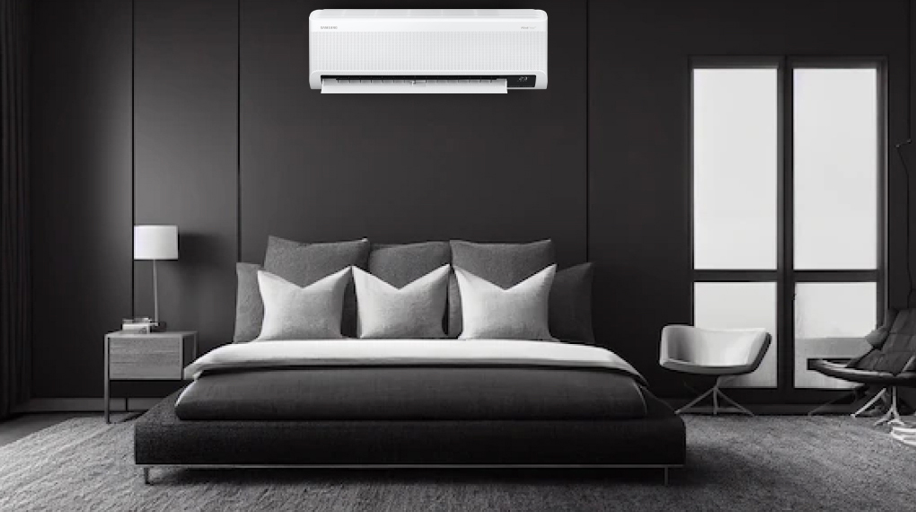](https://cdn.tgdd.vn/Products/Images/2002/304227/may-lanh-samsung-inverter-2-hp-ar18cyfaawknsv-230323-113802.jpg)

*\*Images are for illustration purposes only*

**Refrigeration technology**

- Provides effective cooling range in rooms from 20 - 30m² (from 60 to 80m³) with a capacity of **2 HP** .

- [The air conditioner has](https://www.dienmayxanh.com/may-lanh)**Fast Cooling**  technology   with an improved design with wider air intakes, air blowers, and larger fan sizes to quickly disperse cold air widely.

**Air blowing mechanism**

- Through the customized wind blowing mechanism that  **automatically controls up, down, left and right,**  it helps spread the cold air widely so that users can feel the coolness and relaxation no matter where they stand in the room.

[- Wind-Free](https://www.dienmayxanh.com/kinh-nghiem-hay/wind-freecong-nghe-lam-lanh-cua-tuong-lai-1068729) mode   quickly cools, sending the breeze to every location in the room without creating a cold wind blowing directly on the user thanks to the design of 23,000 microscopic holes on the body of the machine to create a gentle flow of cold air.

**Power saving technology**

[- Digital Inverter Boost](https://www.dienmayxanh.com/kinh-nghiem-hay/may-nen-inverter-8-cuc-tren-may-lanh-samsung-2016-817570) technology   uses an 8-pole Inverter compressor to cool faster than conventional air conditioners while using the same energy level, ensuring smooth, durable and economical operation of the device. electricity.

- Integrated **Eco** mode for optimal chiller, effectively reducing power consumption.

- Energy label:  **5 stars**  (energy efficiency 5.2), electricity consumption  **1.77 kW/h.**

**Air filtering ability**

- Use  the antibacterial **Copper Anti-bacteria Filter to filter out dirt for fresh, pure air, good for your family's health.**The design can be removed and installed flexibly, making it convenient to clean.

**- Auto Clean** function dries the heat exchanger using a strict 3-step process automatically, thereby reducing time and saving costs for cleaning the equipment. Besides, there is also the  **Freeze Wash feature, which** when used will freeze the heat exchanger and then defrost, rinse with water, removing dirt and microorganisms inside for a cleaner machine.

**Utilities**

**- Good Sleep** mode  on  [Inverter air conditioner](https://www.dienmayxanh.com/may-lanh?g=may-lanh-inverter) helps you fall asleep quickly and deeply.

- **Remote control via SmartThings application** : if you forget where to put the remote, you can install this application on your mobile device and control the air conditioner easily.

-  **Smart cooling AI Auto Cooling** : AI artificial intelligence automatically analyzes temperature based on habits, space conditions, and how equipment operates to set the optimal cooling mode, limiting electricity waste.

-  **Dehumidification function** : limits humidity in the room, so you always feel comfortable with a ventilated, dry room space.

There are also utilities such as:  [Timer to turn on and off](https://www.dienmayxanh.com/kinh-nghiem-hay/cac-che-do-thuong-thay-tren-may-lanh-795107#hen-gio) ,  [Auto-restart mode when power is restored](https://www.dienmayxanh.com/kinh-nghiem-hay/cac-che-do-thuong-thay-tren-may-lanh-795107#tu-khoi-dong) ,...

*In general, the Samsung Inverter 2 HP AR18CYFAAWKNSV air conditioner model is very suitable for use in households with rooms from 20 - 30m², the product provides high cooling efficiency, reduces power consumption with Digital Inverter Boost technology, creating Widely dispersed cold air flow, gentle cooling through 23,000 small holes with advanced Wind-Free mode.*